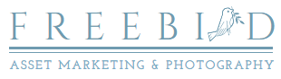
Multifamily Photography Custom Quote Form

Date requested: Click or tap to enter a date.
Please select which package you are requesting.
Choose an item.
How many buildings? Click or tap here to enter text.
How many units? Click or tap here to enter text.
Which amenities would you like us to shoot? Choose an item.
How many interior locations? Click or tap here to enter text.
Which Add-ons would you like? Choose an item.
How many interior photos? Click or tap here to enter text.
How many exterior photos? Click or tap here to enter text.

Thank you for choosing to work with Freebird Asset Marketing & Photography. We will send you a quote for your custom photography package within 2 business days.

